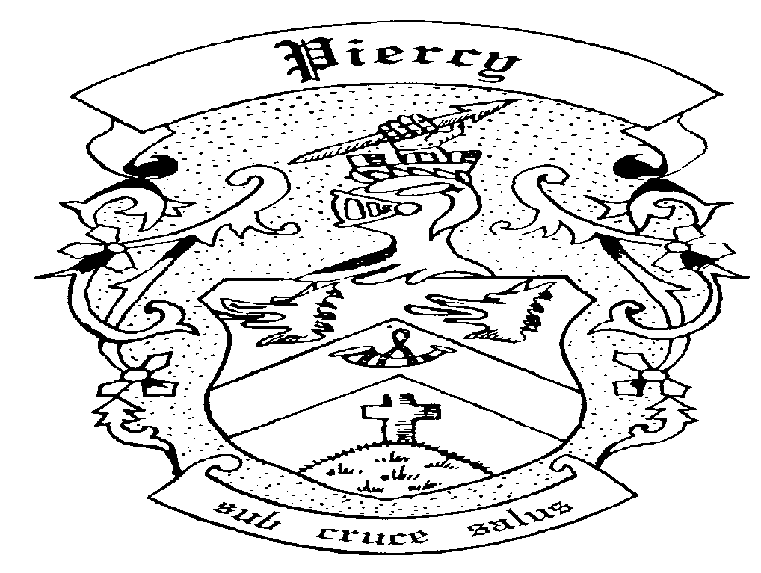

Piercy Family

Reunion

You Are Invited To The

thirteenth

Piercy Family Reunion

At

Grassi Point Farm

(Feely’s Farm)

August 16, 17, 18, 2024

# Pre-registration is required

*Early Bird discounts available*

Visit [www.piercyfamilyreunion.com](http://www.piercyfamilyreunion.com)

**Friday, August 16th**

5:00 – 9:00 p.m. **Pick up tickets/programs at Registration desk**

7:00 p.m. **Corn Roast (included in registration)**

8:00 p.m.  **Entertainment & Social hour**

**Saturday, August 17th**

8:30 – 9:30 a.m. **Breakfast (TBA)**

8:30 - 12:00 noon **Pick up tickets/programs at Registration desk**

9:30 a.m. **Opening Ceremony**

10:00 - 12:00 noon **Family Photo opportunity** (must supply your own camera. No professional photographer)

**Activities Planned for the Day**

* Hay Rides
* Crib Tournament
* All day sports and games
* Pie eating contest
* Zucchini Contest, bring you prize decorated zucchini
* Scarecrow Building Contest, bring your own materials, hay will be provided

5:00 p.m. **Awards Presentation**

6:00 p.m. **Hot Buffet Dinner**

**Dinner: Roast Pork, Seasoned Chicken, Ratatouille on Penne, plus salads, vegetables and bread**

**PRE-ORDERED DINNER TICKETS MUST BE PURCHASED BEFORE July 26, 2024. *SORRY NO EXCEPTIONS***

8:00 p.m. **Barn Dance** – (live band) BYOB

**Sunday, August 18th**

9:00 – 10:30 a.m. **Breakfast (TBA)**

11:00 a.m. **Service of Memorial Tribute**

Please note: Names are not automatically included in this service; it is the responsibility of each family to ensure that their members’ names are on the list, which can be found at the Registration table.

**CLEAN UP TIME – WHEN EVERYONE HELPS IT WON’T TAKE LONG – DO YOUR BIT**

**REGISTRATION COSTS:**

Note: pre-registration is required

Registration includes Corn Roast, tables, chairs, garbage, porta potties, Games supplies and prizes,

Saturday cake and dance

**Adults (12 years and older) $40.00**

**Youth (4 to 11 years old) $20.00**

**Child (3 and under) FREE**

**Early Bird discount 10% off regular rate if received by June 1, 2024**

**Meal costs:**

Saturday and Sunday morning **Pancake and scrambled egg Breakfasts** tickets (each meal)

**Adults (12 years and older) TBA**

**Youth and Children (up to age 11)**

Saturday **Hot Buffet Dinner** tickets

**Roast Pork, Seasoned Chicken, Vegetarian Lasgna, plus salads and vegetables**

Dinner is catered and must be pre-ordered by July 26, 2024

Children 3 and under must have ticket.

**Adults (12 years and older) $40.00**

**Youth (4 to 11 years old) $15.00**

**Child (3 and under) Free**

**Volunteer sign up**

The committee has worked hard to bring this event to you. There are many jobs that need done before, during and after the weekend and we ask that each person take a few minutes to help out. Please email [volunteers@piercyfamilyreunion.com](mailto:volunteers@piercyfamilyreunion.com) to let us know how you can help.

**Thank you**

Rules of fun

Absolutely **NO PETS** please.

Smoking in designated areas only. All butts to be placed in “butt cans”

…**BUTTS MAKE COWS SICK!**

**Pre-Registration**

Please complete registration form and forward with cheque.

Registration forms **must** be received by Aug 2, 2024

Phyllis Baikie

251 Arizona Drive

Campbell River, BC V9H 1V3

Phone: (250) 203-7331

Email: [piercyfr@gmail.com](mailto:piercyfr@gmail.com)

Make cheques payable to Piercy Family Reunion

Etransfers accepted at [piercyfr@gmail.com](mailto:piercyfr@gmail.com). Money will be automatically deposited.

**Family Colours**

Tom Yellow Samuel Blue

John Red Walter Green

Berkeley White McPhee Orange

Henry Purple Matthew Burgundy

James Pink

**Accommodations**

For the campers –Feely’s Farm will be available for Friday and Saturday nights only.

#### [Kingfisher Oceanside Resort](http://www.kingfisherspa.com/) [Old House Village Hotel](http://www.oldhousevillage.com/)

[www.kingfisherspa.com](http://www.kingfisherspa.com) [www.oldhousevillage.com](http://www.oldhousevillage.com/)

1-800-663-7929 1-888-703-0202

[**Travelodge Courtenay**](http://www.travelodgecourtenay.com/)[**Best Western The Westerly**](http://www.bestwesternbc.com/hotels/best-western-the-westerly-hotel/)

[www.travelodge**courtenay**.com](http://www.travelodgecourtenay.com) [www.thewesterlyhotel.ca](http://www.thewesterlyhotel.ca)

**1-800-795-9486** (250) 338-7741

[**Holiday Inn Express**](http://www.hiexpress.com/h/d/ex/1/en/mapsearchresults?ahs=yes&ias=y&_requestid=1599699&availCheckCaching=n&errorURL=/h/d/ex/1/en/mapsearchresults&_requestid=1599699)[**Comox Valley Inn & Suites**](http://www.comoxvalleyinn.com/&t=hotelinfo)

[www.hiexpress.com](http://www.hiexpress.com) [www.comoxvalleyinn.com](http://www.comoxvalleyinn.com)

(778) 225-0010 (250) 334-4476

#### [Anco Motel](http://www.ancomotelbc.com/) [Villas at Crown Isle](http://www.crownisle.com/)

[www.ancomotelbc.com](http://www.ancomotelbc.com) [www.crownisle.com](http://www.crownisle.com)

1-877-393-2200 1-800-378-6811

The Reunion committee does not endorse any of these accommodations.

More information on accommodations by contacting Comox Valley Tourism at [www.discovercomoxvalley.com](http://www.discovercomoxvalley.com)

Phone: 1-855-400-2882 or email: [info@vivccomoxvalley.com](mailto:info@vivccomoxvalley.com)